Supporting the economy and jobs in St. Albert
May 20, 2020 Media inquiries
Twinning of Ray Gibbon Drive in St. Albert is underway. Government committed more than $27 million in Budget 2020 for the expansion, which will support more than 150 jobs for Albertans.
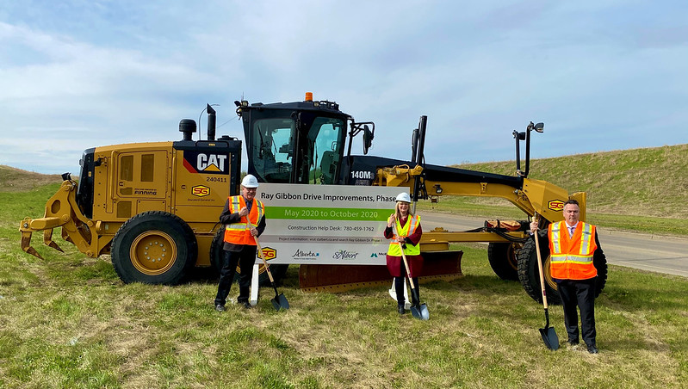
Transportation Minister Ric McIver, along with St. Albert mayor Cathy Heron and Morinville-St. Albert MLA Dave Nally, attended a groundbreaking ceremony to kick off twinning construction for Ray Gibbon Drive between Anthony Henday Drive and Villeneuve Road.
The $54.2-million project will be cost-shared 50-50 between the Government of Alberta and the City of St. Albert. The province’s share of the funding will flow in the final four years of the project, which will enhance safety, improve commute times for families and reduce traffic congestion in the Edmonton Metropolitan Region.
“Ray Gibbon Drive is an important route for St. Albert and this twinning project is one of the top five priorities of the Edmonton Metropolitan Region Board. Our government confirmed over $27 million for the expansion to make it easier for families and businesses to get in and out of the community with less congestion and better driving conditions. Additionally, this project will help create over 150 badly needed jobs for Albertans.”
Ric McIver, Minister of Transportation
“This project has not only been a priority for St. Albert, but for the broader Edmonton Metropolitan Region. We appreciate the support of the Province in partnering with the City to share the costs of this expansion with us over the next decade.”
Cathy Heron, mayor, City of St. Albert
“This long-awaited expansion of Ray Gibbon Drive is significant for St. Albert and surrounding areas. I’d like to thank Minister McIver and the City of St. Albert for making sure this important project is finally completed – it will encourage economic development in the area, support jobs for Albertans, and greatly reduce traffic congestion in St. Albert.”
Dale Nally, MLA, Morinville-St. Albert
More than 20,000 vehicles a day travel Ray Gibbon Drive, which connects St. Albert with Anthony Henday Drive, the Yellowhead Highway and the City of Edmonton.

Media inquiries

Brooklyn Elhard
780-777-4850
Press Secretary, Transportation

